

American International University-Bangladesh (AIUB)  
**Department of Computer Science  
Faculty of Science &Technology (FST)  
Summer 22 23**

**E-Payment System For Transport**

Software Requirement Engineering

Sec: **A**

Project submitted

By

|  |  |
| --- | --- |
| Name | ID |
| A.F.M Zobair | 18-38104-2 |
| Shakhawat Amin | 18-38312-2 |
| Arif Hossen | 19-40741-1 |
| Writhik Banik Barshan | 20-43124-1 |

**Checked By Industry Personnel**

Name:

Designation:

Company:

Sign:

Date:

1. **PROBLEM DOMAIN**
   1. **Background to the Problem**

Introducing “E-Payment System For Transport” which creates a digital platform that facilitates electronic payments for various transportation services. This system aims to simplify and streamline the payment process for passengers, while also providing benefits to transportation providers and authorities.

The idea for developing a seamless integration of several payment methods into the transportation system, including credit/debit cards, digital wallets, and mobile money. It is essential to provide safe and dependable payment processing.

E-payments system's mission is to help travelers with any problems relating to the e-payment system, such as account administration, payment inconsistencies, and technical concerns.

This system meets the needs of users of many modes of transportation, including ride-sharing services and buses, trains, and more within a single financial ecosystem.

This uses QR codes to enable contactless payments that eliminate the need for paper tickets or cash for quick and easy fare payment.

This system also offers to put strong security measures to safeguard private payment data and stop fraudulent activities like unauthorized access or transactions. The e-payment system integrates with the current transportation infrastructure, such as fare collection devices, ticketing systems, and databases, without interfering with how things are already being done.

The e-payment system integrates data analytics skills to learn more about customer behavior, travel trends, and payment patterns. Transportation authorities can use this data to optimize services and make wise judgments.

If you are looking for a software that offers convenience, efficiency, and security by allowing seamless electronic transactions for transportation services, eliminating the need for physical cash and reducing time spent on payment processing; look no further than "E-Payment System For Transport".

* 1. **Solution to the Problem**

Designing a comprehensive solution for an e-payment system in the transport domain requires a thoughtful approach to address the various challenges and provide a seamless user experience. Here are some solutions to the problem:

* **Multi-Modal Payment Platform**: Create a consolidated e-payment network that enables multiple modes of transportation under one roof using the phrase "multi-modal payment platform. To link with current transportation systems for fare calculation, validation, and real-time updates, develop integration protocols.
* **Contactless** **Payment Options:** NFC technology and QR code scanning should be used to enable quick and simple contactless payments utilizing smartphones or smart cards. Passengers should be able to manage their accounts, check their balances, and view transaction history using a mobile app.
* **Flexible Fare Calculation:** Use cutting-edge algorithms to determine prices depending on variables like distance, travel time, and method of transportation. To maximize passenger flow, incorporate dynamic pricing for peak and off-peak hours.
* **Security and Privacy Measures:** To secure payment data and prevent illegal access, use strong encryption and tokenization techniques. For account access and transactions, use two-factor authentication. Maintain security standards through routine audits and updates to remain ahead of any emerging threats.
* **User-Friendly Interfaces:** Create user interfaces that are simple to navigate and have accessible functionality for both passengers and transportation personnel. Make it simple for users to set up auto-reload options, add payment methods, and create accounts.
* **Integration and Interoperability**: Collaborate with transportation authorities to seamlessly integrate the e-payment system into their existing infrastructure. Ensure compatibility with regional and national transport networks, allowing for cross-system usage.
* **Analytics and Reporting**: Implement data analytics tools to gather insights into passenger behavior, usage patterns, and payment trends. Provide transportation authorities with reports to optimize routes, schedules, and infrastructure.

1. **SOLUTION DESCRIPTION**

E-payment system for transport is a digital payment system for paying bus fares.

* A user can pay cash less.
* No argument will occur with bus conductor for fares.
* Exact route fair with km calculations will be included in the software.
* If someone has less/no money, he/she can recharge within the app or can take emergency loan from the FinTech Company which will be connected.
* Dedicated account will be there for different users.
* A user can pay using the QR code which will be present in every bus seats.
* Main software program will be written using C#.
* Software UI Design will be designed in Figma.
* Maps are used for designing transects, indicating observations and presenting results. These maps are fetched by free map suppliers like Google maps.
* FinTech Company like Bkash will be integrated with our software.
* Route information will be taken from BRTA server.

A survey will be conducted with users before launching the software. A user will first open an account with necessary information. Then they’ll connect their Bkash account. Then they can start paying the fares by scanning without any hassle. It’s that simple. Our app will be available only on Play store (Android).

* 1. **System Features**

The main function of E - Bus ticket payment system is allowing the passengers to enter their data by scanning QR code and pay through online account. First every passenger has to enter the system by scanning the QR code than the identity information enters the system and check the validity of the passenger. After getting the individual information and identity, the system looks for the category of the particular passenger. If the passenger is the student then the discount price is added to the destination charge fee and generates. After paying the bill the system sends a confirmation code to the mobile operator. The payment has to done by any mobile operator. Effectively after the confirmation code sent, the contractor has to recheck the payment system by scanning the QR code system. After reconfirming the payment is added to the owners saving account direct through any mobile operator. The whole booking system is also checked and reconfirmed by the BRTA management authority by an email confirmation.

* 1. **UML Diagrams**

**Use Case Diagram**

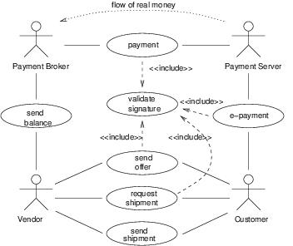

**ER Diagram**

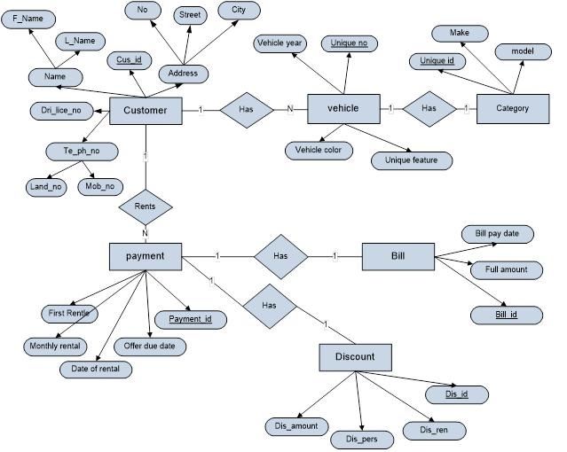

**Class Diagram:**

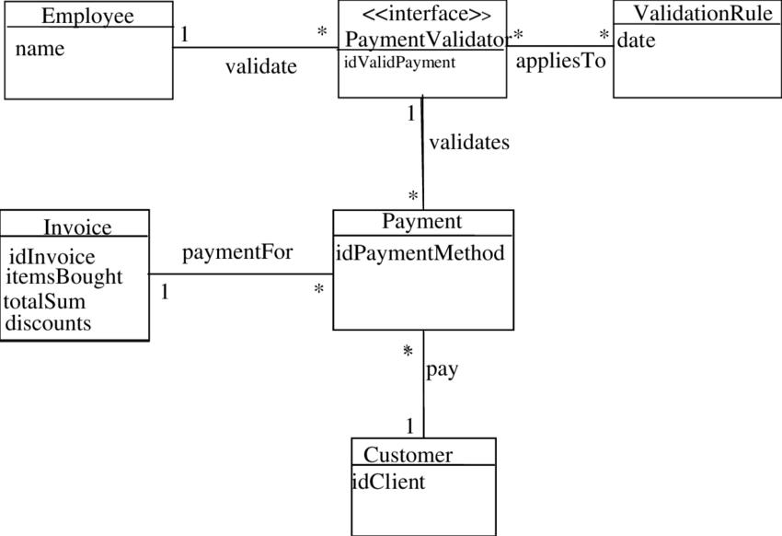

1. **Social Impact**

An E-Payment System for transportation can have a significant social impact in several ways:

* **Financial Inclusion:** E-Payment systems make it easier for people who may not have access to traditional banking services to participate in the formal economy. This is especially relevant in many developing countries where a significant portion of the population is unbanked or underbanked. E-Payment systems allow them to pay for transportation services without the need for physical cash, promoting financial inclusion.
* **Reduced Cash Handling**: Traditional transportation payment methods often involve handling and carrying cash, which can be risky due to theft and loss. E-Payment systems eliminate the need for cash transactions, making transportation safer for both passengers and drivers.
* **Transparency and Accountability:** E-Payment systems can provide a transparent record of transactions, reducing the likelihood of fraud and corruption. This is particularly important in the transportation sector, where fare evasion and improper revenue collection can be significant problems.
* **Efficiency and Convenience:** E-Payment systems streamline the payment process, reducing waiting times for passengers and improving overall efficiency. This is especially valuable in busy urban areas where traffic congestion and long queues can be common issues.
* **Environmental Impact:** E-Payment systems can encourage the use of public transportation over private vehicles, leading to a reduction in air pollution and traffic congestion. By making public transportation more accessible and convenient, more people might be inclined to use it, contributing to a cleaner and more sustainable environment.
* **Data Collection for Planning:** E-Payment systems generate data on travel patterns, popular routes, and peak travel times. This data can be invaluable for transportation planners and policymakers to make informed decisions about route optimization, scheduling, and infrastructure development.
* **Empowerment of Women and Vulnerable Groups**: E-Payment systems can provide a safer and more accessible way for women and vulnerable groups to travel. These groups often face security concerns when using cash-based transportation systems. E-Payments can reduce these risks and promote their mobility.
* **Job Creation and Economic Growth:** The development, maintenance, and support of E-Payment systems can create employment opportunities in technology, customer support, and related sectors. Moreover, efficient transportation systems can boost economic activity by facilitating easier movement of people and goods.
* **Reduced Traffic Congestion:** E-Payment systems can integrate with smart city initiatives, allowing for better traffic management and reduced congestion. This can lead to shorter travel times, less frustration, and lower emissions.
* **Promotion of Innovation:** E-Payment systems encourage technological innovation and the development of related services such as mobility apps, real-time tracking, and integrated ticketing systems. This fosters a culture of innovation and entrepreneurship within the transportation sector.

In conclusion, an E-Payment System for transportation can bring about a range of social benefits, from financial inclusion and increased transparency to reduced traffic congestion and environmental impact. By modernizing payment methods in the transportation sector, societies can enjoy improved mobility, safety, and economic growth.

1. **Development Plan with Project Schedule**

Developing a E-payment system requires careful planning, design, and development. Here is an outline of a potential development plan with a project schedule for a new startup E-payment system:

* Planning Phase (1-2 weeks)
* Design Phase (2-4 weeks)
* Development Phase (6-8 weeks)
* Integration Phase (2-3 weeks)
* Launch and Testing Phase (1-2 weeks)
* Maintenance and Support Phase (ongoing)



In summary, developing a E-payment system requires careful planning, design, development, integration, launch, testing, maintenance, and support. Following a detailed project schedule can help ensure that the system is delivered on time, within budget, and meets user requirements.

1. **Marketing Plan**

Developing an effective marketing plan is critical for the success of any new startup E-payment system. Here is an outline of a potential marketing plan:

* Market Analysis.
* Define Target Audience.
* Branding.
* Content Marketing.
* Search Engine Optimization (SEO).
* Social Media Marketing.
* Influencer Marketing.
* Paid Advertising.
* Email Marketing.
* Referral Marketing.

Developing a comprehensive marketing plan that includes market analysis, defining target audience, branding, content marketing, SEO, social media marketing, influencer marketing, paid advertising, email marketing, and referral marketing can help your new startup e-payment system attract and retain customers, build brand awareness, and drive sales.

1. **Cost and Profit Analysis**

To perform a cost and profit analysis for a new startup e-payment system, we need to consider various factors that impact the company's revenue and expenses. Here are some important things to consider:

* Development Costs.
* Marketing and Advertising Costs.
* Staffing Costs.
* Server and Hosting Costs.
* Payment Processing Fees.
* Customer Acquisition Costs.
* Revenue Streams.
* **Development Costs**: This includes the cost of designing, developing, and testing the E-payment system. Assuming a team of local developers and designers working on the project, the cost could range from **BDT 500,000 to BDT 1,000,000.**
* **Marketing and Advertising Costs**: This includes the cost of promoting the system through various channels, such as social media, online ads, and other marketing strategies. Depending on the scale and scope of the marketing campaigns, the cost could range from **BDT 50,000 to BDT 200,000.**
* **Staffing Costs**: This includes the salaries and benefits of employees, including developers, marketers, customer service representatives, and other staff members. In Bangladesh, the cost of hiring skilled employees is relatively low compared to other countries. Assuming a team of 5 employees, the cost could range from BDT **1,000,000 to BDT 2,000,000 per year**.
* **Server and Hosting Costs**: This includes the cost of hosting the system on servers and any additional expenses such as domain name registration. The cost of hosting and server maintenance in Bangladesh is relatively low, and could range from BDT 50,000 to BDT 100,000 per year.
* **Payment Processing Fees**: This includes the fees charged by payment processors such as Bkash for processing transactions. The cost of payment processing fees varies depending on the payment gateway and the volume of transactions processed. Assuming a fee of 2%, the cost could range from BDT 20,000 to BDT 50,000 per year.
* **Customer Acquisition Costs**: This includes the cost of acquiring new customers through promotions, referral bonuses, or other incentives. Depending on the scale and scope of the customer acquisition campaigns, the cost could range from BDT 50,000 to BDT 100,000.

Based on these estimates, the total expenses for the first year could range from BDT 1,670,000 to BDT 3,450,000. Therefore, the profit would be BDT 2,500,000 (revenue) - BDT 1,670,000 to BDT 3,450,000 (expenses) = BDT 830,000 to BDT 780,000.

It's important to note that these are just estimates, and the actual costs and revenues may vary based on several factors such as market conditions, competition, and other variables. However, a low-budget startup e-payment system can still be profitable if it is able to acquire customers at a low cost and generate revenue through efficient monetization models.

1. **Reference**
2. Croock, M. S., & Taaban, R. A. (2021). Software engineering based secured E-payment system. International Journal of Electrical and Computer Engineering, 11(5), 4413.
3. Alhafi, R., Almutairi, S., Alsultan, N., Alsmadi, M. K., Alshabanah, M., Alrajhi, D., & Almarashdeh, I. (2019). E-Payment and Transactions using QR Codes. International Research Journal of Engineering and Technology, 6(2), 433-443.
4. Husni, E., & Hidayat, M. A. (2018, July). E-payment system using SMS gateway and line application. In 2018 International Conference on Information and Communication Technology for the Muslim World (ICT4M) (pp. 173-178). IEEE.
5. Al Farawn, A., Rjeib, H. D., Ali, N. S., & Al-Sadawi, B. (2020). Secured e-payment system based on automated authentication data and iterated salted hash algorithm. TELKOMNIKA (Telecommunication Computing Electronics and Control), 18(1), 538-544.
6. O'mahony, D., Peirce, M., & Tewari, H. (1997). Electronic payment systems (pp. I-XII). Norwood: Artech House.